Milestone 3 Documentation

Revised Schedule (Essentially a week ahead)

Week 1: Have problem statement complete

Week 2: Plan out the different classes and their interaction. Have components tabbed out. Develop base platform for entire project to allow divide and conquer.

Week 3: Get the game board background displaying and cards displaying. Internally handle cards being played. Have event handlers to allow users to click on cards to play them. Have turns able to be played.

Week 4: Add additional card functionality. Increase code coverage.

Week 5: Add basic “working” AI that chooses cards to play and makes decisions.

Week 6: Finish out AI to make it good, possibly adding different difficulty levels.

Current Code Coverage

Our present code coverage is at 73%, which is inherently skewed upward because it’s counting the tests themselves. We’re also still only at 45% branch coverage, which needs to be improved. Most of the actions within deck and player deck are completely covered, but most of the things in game and turn still need to be covered. Below are tables with instruction and branch coverage.

Instruction coverage:

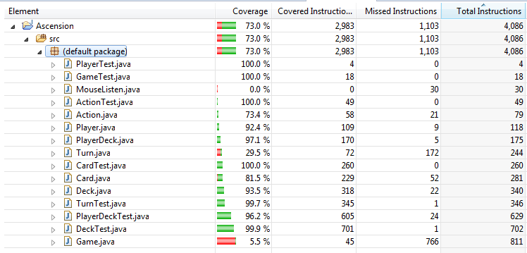

Branch Coverage

